**CS5560 Knowledge Discovery Management**

**In Class Assignment # 11**

**16th April 2020**

**Name:** Srichakradhar Reddy Nagireddy  
**ID**: 11

Perform the following:

1. Use the source code for CNN and run it on a different data set and report the following:
2. accuracy of the model
3. Describe the Data set
4. Hyper parameters that you have used
5. Any other observation that you have made

# CNN:

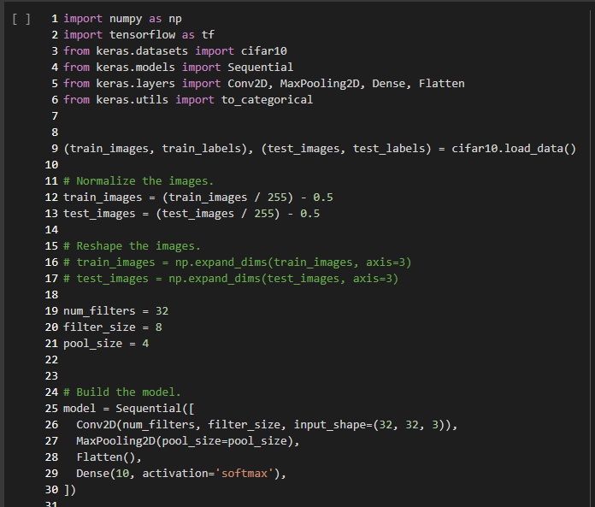

**CIFAR10**

**Input Size:** 32x 32 x 3

**Output Size**: 1 x 1

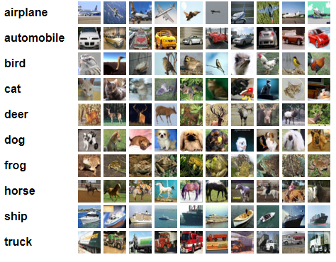

Hyperparams:

num_filters = 32

filter_size = 8

pool_size = 4

input_shape=(32, 32, 3)

**Results**:

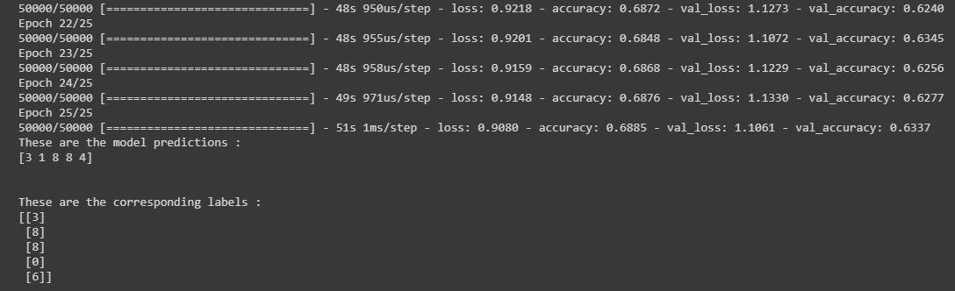

# Autoencoder:

# 

**Results**:

